Customer Personality Segmentation
Machine learning project
Data Description
Customer Personality Analysis is a detailed analysis of a company’s ideal customers. It helps a business to better understand its customers and makes it easier for them to modify products according to the specific needs, behaviors and concerns of different types of customers.
Customer personality analysis helps a business to modify its product based on its target customers from different types of customer segments. For example, instead of spending money to market a new product to every customer in the company’s database, a company can analyze which customer segment is most likely to buy the product and then market the product only on that particular segment.
Features
People
ID: Customer's unique identifier
Year_Birth: Customer's birth year
Education: Customer's education level
Marital_Status: Customer's marital status
Income: Customer's yearly household income
Kidhome: Number of children in customer's household
Teenhome: Number of teenagers in customer's household
Dt_Customer: Date of customer's enrollment with the company
Recency: Number of days since customer's last purchase
Complain: 1 if the customer complained in the last 2 years, 0 otherwise
Products
MntWines: Amount spent on wine in last 2 years
MntFruits: Amount spent on fruits in last 2 years
MntMeatProducts: Amount spent on meat in last 2 years
MntFishProducts: Amount spent on fish in last 2 years
MntSweetProducts: Amount spent on sweets in last 2 years
MntGoldProds: Amount spent on gold in last 2 years
Promotion
NumDealsPurchases: Number of purchases made with a discount
AcceptedCmp1: 1 if customer accepted the offer in the 1st campaign, 0 otherwise
AcceptedCmp2: 1 if customer accepted the offer in the 2nd campaign, 0 otherwise
AcceptedCmp3: 1 if customer accepted the offer in the 3rd campaign, 0 otherwise
AcceptedCmp4: 1 if customer accepted the offer in the 4th campaign, 0 otherwise
AcceptedCmp5: 1 if customer accepted the offer in the 5th campaign, 0 otherwise
Response: 1 if customer accepted the offer in the last campaign, 0 otherwise
Place
NumWebPurchases: Number of purchases made through the company’s website
NumCatalogPurchases: Number of purchases made using a catalogue
NumStorePurchases: Number of purchases made directly in stores
NumWebVisitsMonth: Number of visits to company’s website in the last month
Target
Need to perform clustering to summarize customer segments.

Data Source
Kaggle :https://www.kaggle.com/datasets/imakash3011/customer-personality-analysis

Tools Used
- Python is used while creating the environment and libraries like NumPy, Pandas, Scikit-learn.
- Pymongo, Exceptions and logger are used for developing the model.
- VS code is used to development the modular model.

Problem Description
Customer Personality Analysis based on purchasing power aims to understand the income levels, spending behavior, and affordability of different customer segments. This analysis helps businesses develop more effective marketing strategies by identifying high-potential customer groups with stronger purchasing power, optimizing marketing efforts, and increasing revenue.

Key Focus Areas
- Income Level Segmentation: Categorize customers by income to identify high-disposable income segments.
- Spending Behavior Analysis: Understand spending patterns to tailor marketing messages effectively.
- Affordability Assessment: Set appropriate pricing strategies based on different income groups' budgets.
- Targeted Promotions and Offers: Design promotions to incentivize purchases from specific customer segments.
- Market Expansion Opportunities: Identify untapped purchasing power for strategic growth and diversification.
By focusing on customer income and purchasing power, businesses can optimize their marketing efforts, increase customer engagement, and drive revenue growth by offering products and services that align with the financial preferences of their target audience.

Problem Approach
Feature Engineering: Engineer relevant features from the collected data to enhance the predictive power of the models. This may include creating new variables that capture spending-to-income ratios or grouping customers based on income ranges.
PCA Analysis : Apply Principal Component Analysis (PCA) to understand the variance within the dataset and identify essential features that contribute most to income prediction. This step aids in dimensionality reduction and enhances model performance.
Clustering with Machine Learning Models: Utilize clustering algorithms (e.g., K-means, hierarchical clustering) on the PCA-transformed features to segment customers based on their income patterns. This step groups customers with similar income characteristics, enabling targeted marketing strategies for each segment.
Model Training and Validation: Train machine learning models on the segmented data to predict customer income levels within each cluster. Use appropriate validation techniques to assess model performance and generalization.
UI for User Interaction: Develop a user-friendly interface that allows stakeholders to interact with the trained models and explore customer segments. The interface should enable users to input customer attributes and receive information regarding segmentation customer belong to.

Data Base
CSV zip file is downloaded from github. Url for same is mentioned in config.yaml

GitHub Repository

Training Pipeline
Components of Pipeline
- Data Ingestion
- Data Validation
- Data Transformation
- Model Training
- Model Evaluation
- Model Pusher

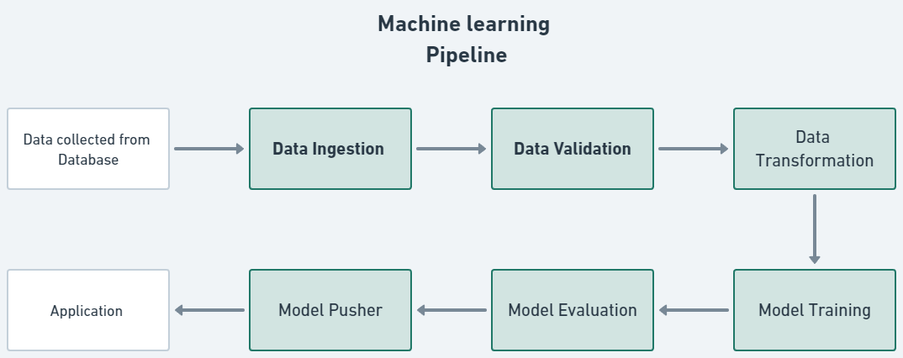

Data Ingestion 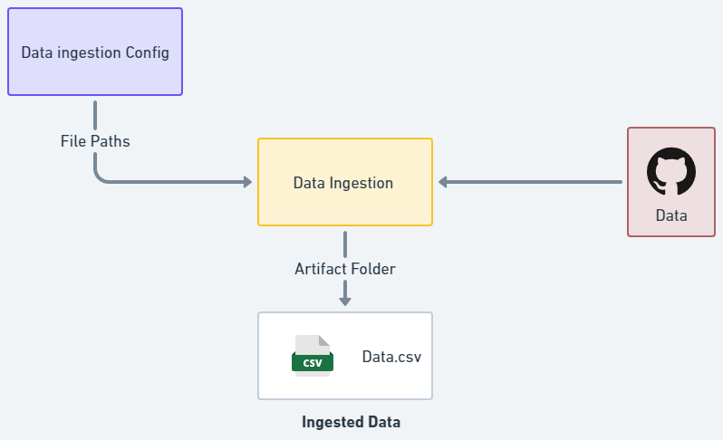
Data Ingestion class represents a data ingestion process that involves retrieving data from a data source, saving it in a raw data directory, and splitting it into training and test datasets.
The class code flows in following way:
Data Ingestion class takes a necessary elements and that provides the configuration settings for the data ingestion process.
It retrieves data from a data source and saves it in a raw data directory. It accesses the configuration settings to determine the location of the raw data directory and performs the necessary operations to obtain the data from the data source and saves it in the specified directory.
Training set

Throughout the process, the class handles any exceptions that may occur and raises an application exception with an appropriate error message.

Data Validation 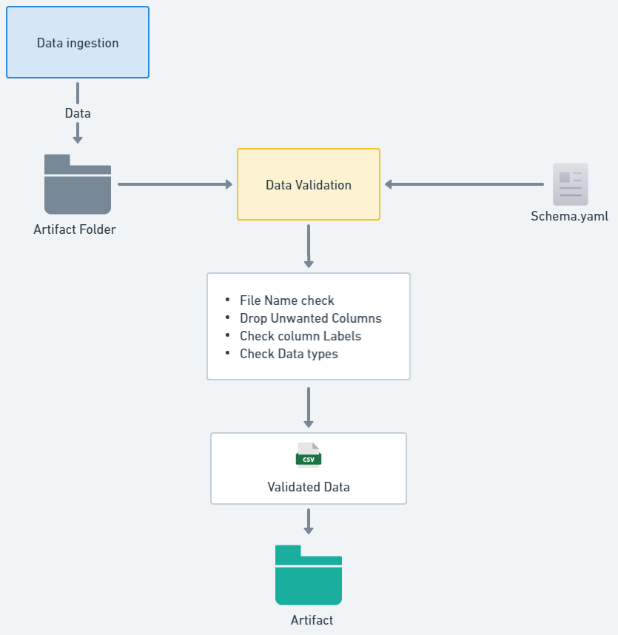
This method aims to validate the training and test data stored in the artifact folder as a result of the data ingestion process carried out earlier. Its responsibility is to perform validation checks on the training and test datasets.
The method follows a series of steps to validate the data and logs the validation process. If the validation is successful, it exports the validated datasets to specified paths and returns the paths. However, if the validation fails, it raises an exception.
Validation processes :
- File name of the downloaded dataset
- Column labels
- Validating Data types
- Missing values whole column
- Replace null values
Each of these methods returns a boolean value as the result of the validation. If the dataset passes all the checks and evaluates to True, it is stored in the artifact folder.
Throughout the process, the class handles any exceptions that may occur and raises an application exception with an appropriate error message.

Data Transformation
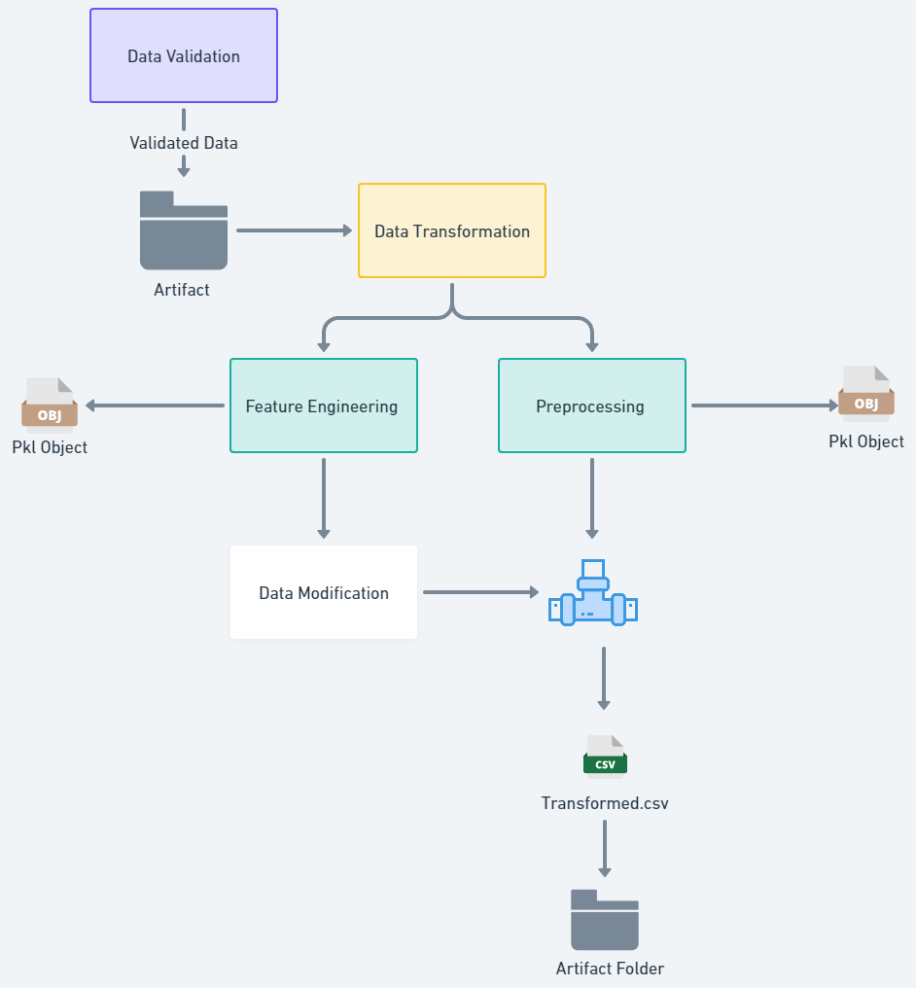

Once the validated data is obtained from the artifact folder, it proceeds for the necessary transformations before being used for model training. These transformations ensure that the data is in a suitable format and structure for the training process.

Feature Engineering
The feature engineering class leverages insights from exploratory data analysis (EDA) to transform the dataset, enriching it with new and meaningful information. These engineered features have the potential to improve the model's performance and predictive capacity.
To ensure consistent utilization of these features, a feature engineering object file is created, allowing for batch prediction on new data without repeating the entire feature engineering process. This approach promotes consistency, reproducible, and efficient application of pre_processing steps to the data.

Preprocessing Pipeline
After feature engineering the data, the next step is pre_processing . The pre_processing pipeline applies a series of steps to the training and testing datasets, ensuring they are in a consistent and suitable format for model training.
The pre_processing pipeline plays a critical role in optimizing the data for model training by standardizing and cleaning it. This enables the model to learn patterns effectively during training and make accurate predictions.
Overall, the data transformation stage ensures that the validated data undergoes necessary transformations, while feature engineering enhances the dataset by creating new features. The pre-processing pipeline then applies a series of standardized steps to prepare the data for model training.
Output
Object Files
Feature Engineering Pipeline ---> pkl object

Pre_processing pipeline ---> pkl object


Transformed Data
Train Data

Model Training
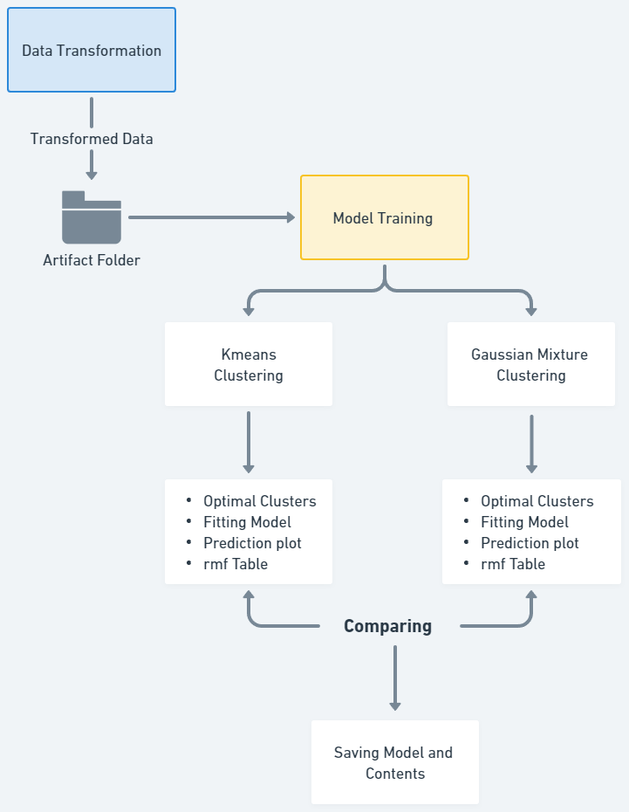
Transformed train and test datasets is further used for model training
Models
For this Clustering problem statement based on the Data analysis we detect few relevant models for model training :
- Kmeans
- Gaussian Mixture Clustering

Hyper_parameter Tuning
Hyper_parameter tuning involves finding the optimal combination of hyper parameters for a given model..
Metric used : Silhouette Score
Output :
Model Object

The best model, along with its corresponding best parameters, is saved for future use. This ensures that the optimal model can be easily retrieved and applied to new data.
Model Report

Report containing relevant information and insights is also saved. This report provides a concise summary of the model's performance and any additional context or analysis that may be necessary for understanding the model's results.
Model object and report is saved to the artifact directory
Prediction plot

Cluster plots of Frequency , Recency and Monetary columns to understand cluster labeling for predictions

Model Evaluation
The saved model directory may contain earlier models and other necessary components from previous iterations.
During the evaluation process, we compare the recently trained artifact model with the previously saved models. By leveraging this comparison, we identify the best-performing model.
Once the selection is made, we save the chosen model along with its associated model object and a comprehensive model report.
This approach ensures that we retain the most optimal model for future use.

Model Pusher 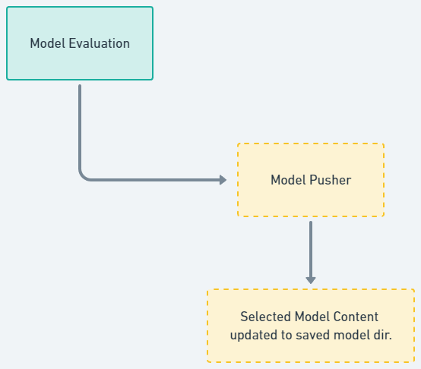


Upon selecting the models and gathering the relevant information from the evaluation module, we proceed to push the chosen model and its corresponding report to the saved model directory. This ensures that the selected model is readily available for future prediction processes.

Saved Model Directory

Model

Model Report

Prediction Image

By storing it in the designated directory, we facilitate easy access and utilization of the model in subsequent tasks.

Application
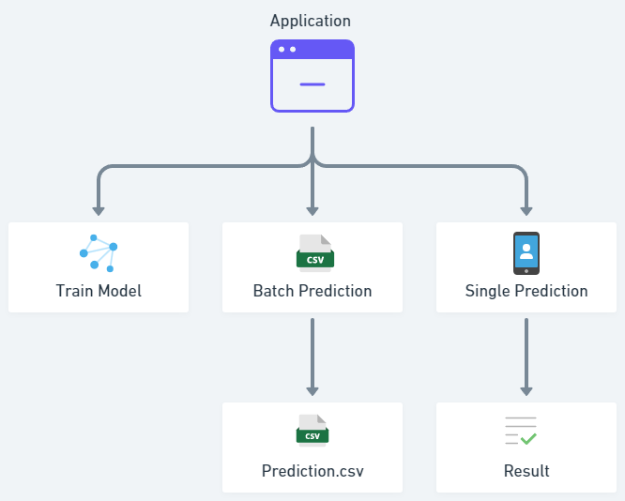
UI
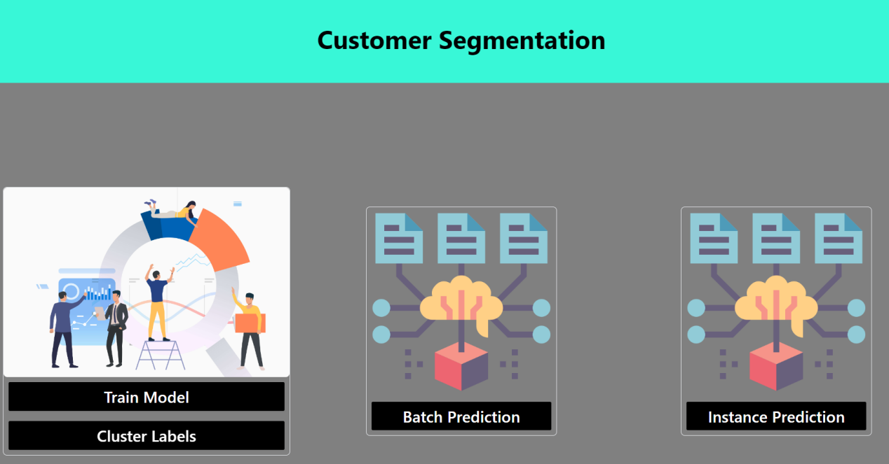

Train Model
This option triggers an entire training pipeline to train the model
Instance Prediction
After training the model and saving the necessary contents and information, the system utilizes the user's input to generate predicted results.
These results are then displayed on an HTML web page for easy access and visualization
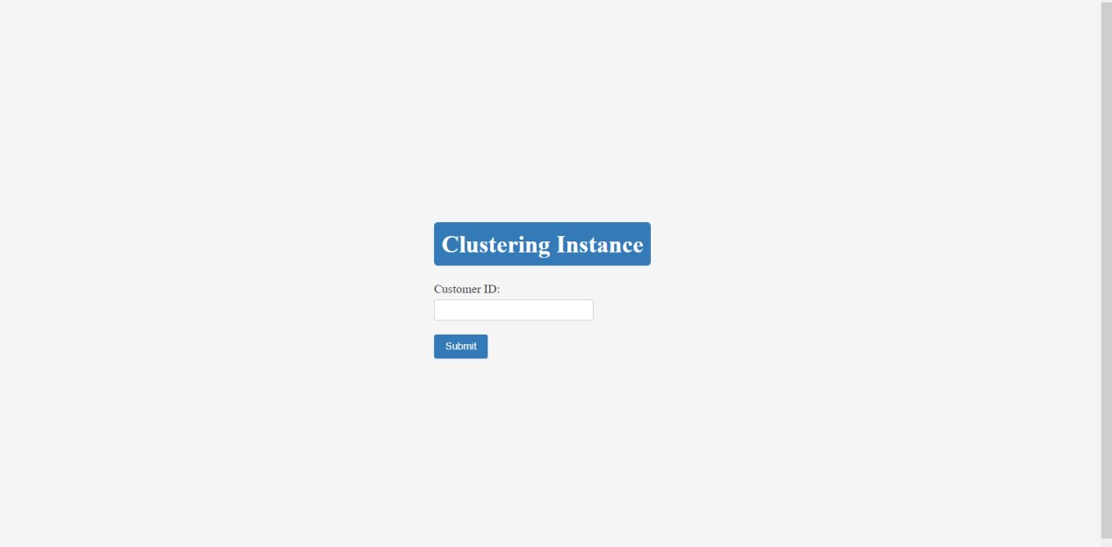

Batch Prediction
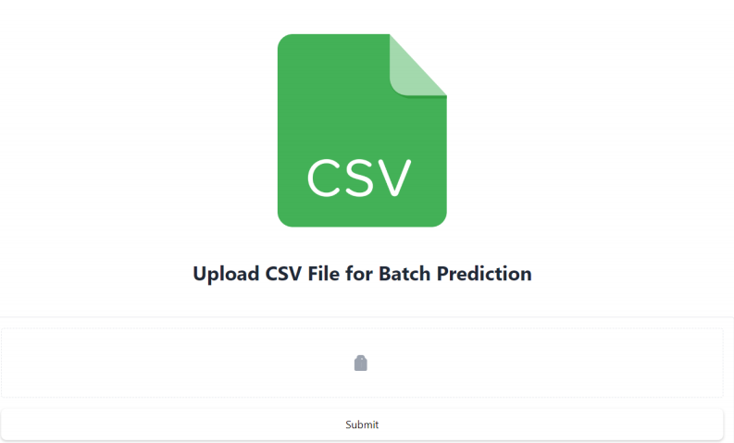
In batch prediction, the user provides a CSV file as input, and the system generates a prediction CSV file. The resulting file is then stored at a specified location and can also be uploaded to a MongoDB database for further use or analysis.

Steps to execute the Project

Terminal
- Python command
- python main.py --> run UI

Browser
- Localhost:app_port

UI



- Train the model

Trained Model and Other contents are stored in the Saved_Model Directory

- Label the clusters
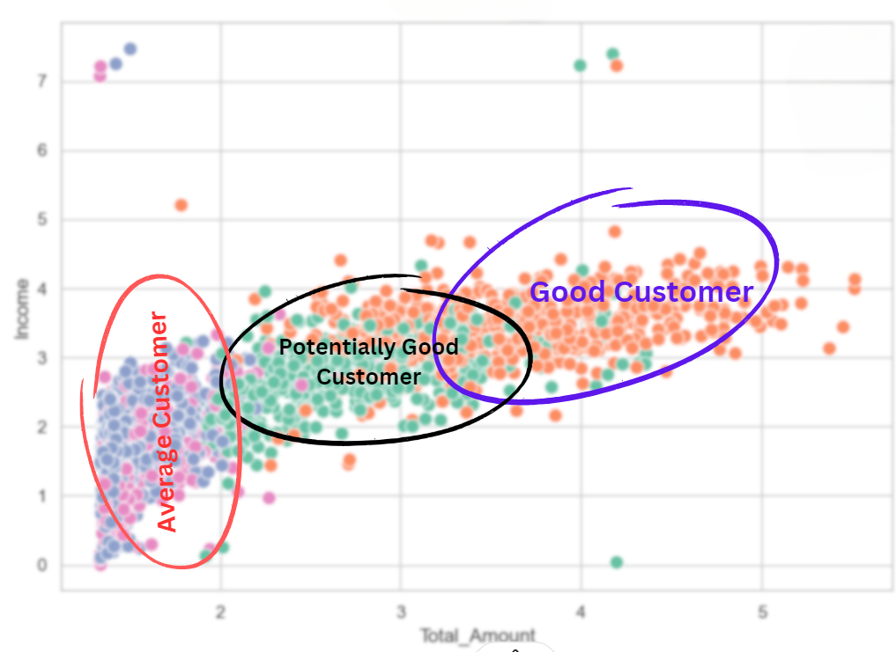

4 clusters
- High Income, High Amount Spent: Good Customer
"Affluent Customers" or "High-Spending Clients"
Description: These customers have high incomes and spend a substantial amount of money on their purchases. They are affluent and valuable customers, making them a prime target for special treatment and personalized offers to maintain their loyalty and increase their spending.

b. Moderate Income, Moderate Amount Spent: "Middle-Income Customers" or "Steady Spenders" - Potentially Good Customer

Description: These customers have moderate incomes and spend an average amount on their purchases. They show consistent spending behavior and should be encouraged to increase their loyalty. Nurturing them may lead to becoming higher-value customers over time.

- Low Income, Low Amount Spent: - Average Customers
(Two clusters belong to this Segmentation)
"Budget-Conscious Customers" or "Economical Buyers"
Description: These customers have low incomes and spend relatively little on their purchases. Targeted marketing efforts should focus on offering affordable products or services to attract them and improve their loyalty.

- Batch Prediction
Featured Engineered csv is stored in the batch prediction Folder
Prediction csv is Stored in the batch_prediction Folder

- Instance Prediction

Input the Customer ID , if customer present in the trained data his category will be visible else customer is labeled as new customer

Resume

Project Summary

Objective: The project aims to perform Customer Personality Analysis based on purchasing power to understand income levels, spending behavior, and affordability of different customer segments.

Data: The collected data includes customer attributes (e.g., ID, Year_Birth, Education, Marital_Status, Income), product purchase information (e.g., MntWines, MntFruits, MntMeatProducts), response to promotions (e.g., AcceptedCmp1, AcceptedCmp2), and online behavior (e.g., NumWebPurchases, NumWebVisitsMonth).

Feature Engineering: Relevant features are engineered, such as spending-to-income ratios and grouping customers based on income ranges.

PCA Analysis: Principal Component Analysis (PCA) is applied to identify essential features that contribute most to income prediction, reducing dimensionality and enhancing model performance.

Clustering: Clustering algorithms (e.g., K-means, Gaussian Mixture) are used on the PCA-transformed features to segment customers based on income patterns.

Model Selection: The Silhouette Score is used as the metric for model selection. It measures the quality of the clustering results by evaluating the cohesion and separation of data points within clusters. The clustering algorithm with the highest Silhouette Score is chosen as the most appropriate for customer segmentation.

Business Insights: The project provides valuable insights into customer behavior, enabling businesses to develop targeted marketing strategies, optimize efforts, and increase revenue. The use of the Silhouette Score ensures that the chosen clustering algorithm provides the best segmentation results for improved decision-making.

